Practical-7

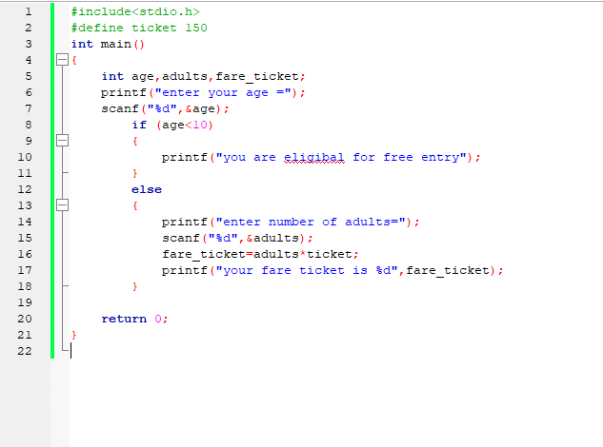

Ss1:input

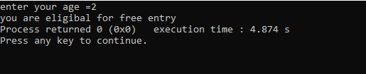

Ss2:

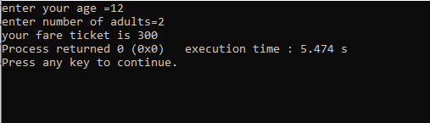

Ss3:

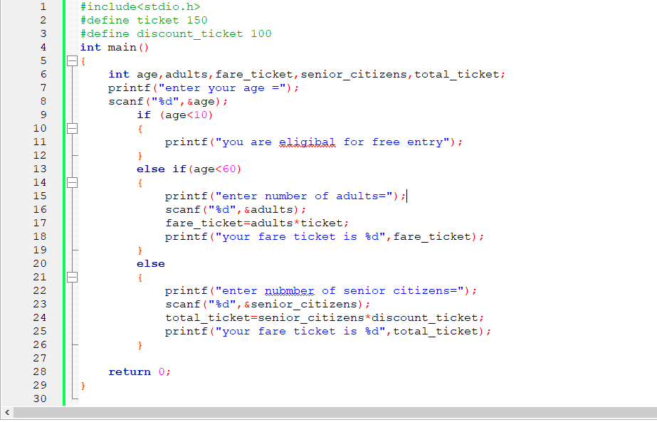

Ss4:

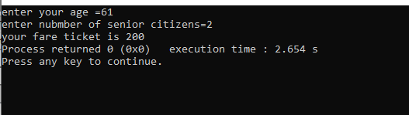

Ss5: